

**2. Story and Gameplay**

University Run is a mobile 2d jump and run game with 3d objects and elements. Studying and receiving a university degree in the end is the overall goal of University Run. Therefore the player takes the role of a virtual student, chooses his subject of study and has to complete semesters with acceptable grades.

The levels consist of platforms, walls, enemies, items and many more things in almost endless combinations for a constantly changing and interesting game experience. The player uses two-directional running and jumping interactions to move on. Different themes like classroom, library and party cover all aspects of student’s life.

During the levels the character collects grades which are used to calculate the final grade. So try to get all A’s and B’s but stay away of E’s and F’s although bad grades are of course easier to collect than good ones. On top of that the player has to keep in mind that he might be running out of time soon and has to jump and move quickly before he fails. The combination of different items and possibilities, the funny design and also some difficult sections make it an addictive mobile game for players of different ages.

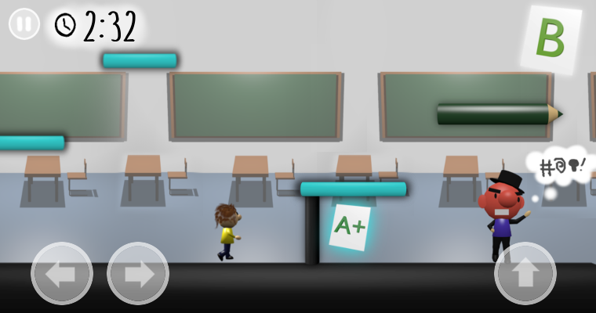

**7. Interface**

After the player has started the game and chosen a level he is shown a screen looking very similar to the example below. Although game situations are changing some elements of the user interface always stay in place: three game control buttons at the bottom of the screen, one pause button in the top left corner, a time counter next to this button and a grade sheet in the top right corner. In the following paragraphs these elements are described more precisely.

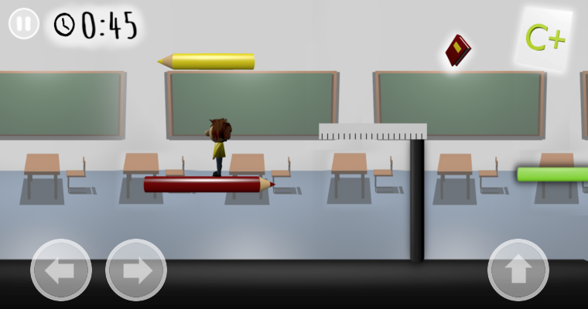

The three buttons at the bottom are the elements that enable all game interactions for the player. On the left side there are two buttons which are pressed to make the small “student” in the game running to the left and right side. When the right button is pressed the character will jump. Pressing the left/right button and the jump button at the same time will result in a jump in the respective direction.

The pause button is obviously used when the player wants to have a break, quit or choose a different level. A menu will show up with a resume, level/semester overview and quit option.

The timer next to this button shows how much time is left to finish the level and is constantly decreasing. The timer value can also be manipulated by collecting items and running into enemies which is described in the respective sections of this document.

Finally another important interface element can be found in the top right corner. The grade display shows the player how successful he has been so far. In the beginning of a level there will be no grade in the corner but during the level it is calculated based on the collected grades (further details in section 8). It is displayed as a card with the grade on it and marked in green color for very good, yellow color for okay and red color for very bad.